 | 7.1.34 Editors - 3D Viewport - Header - Armature - Edit mode - Armature menu
Table of content
Detailed Table of content 1
Edit Mode - Armature Menu 5
Transform - Submenu 5
To Sphere 5
Shear 6
Bend 7
Push/Pull 7
Warp 8
Randomize Transform 8
Align Bones 9
Mirror 9
Interactive Mirror 9
X Global, Y Global etc. 9
Snap 10
Last operator Snap Selection to Cursor 10
Recalculate Bone Roll - Submenu 10
Set Bone Roll 11
Clear Roll 12
Single Operators 12
Extrude 12
Extrude to Cursor 13
Duplicate 13
Fill between Joints 15
Split 15
Separate Bones 15
Symmetrize 15
Subdivide 16
Switch Direction 16
Names - Submenu 16
About Bone Collections 17
Move to Bone Collection 17
Bone Collections – Sub Menu 17
Make Parent 18
Clear Parent 19
Bone Settings - Submenu 19
Show/Hide – Submenu 19
Delete Selected Bone(s) 20
Dissolve Selected Bone(s) 20

Detailed Table of content

Detailed table of content
Detailed Table of content 1
Edit Mode - Armature Menu 5
Transform - Submenu 5
To Sphere 5
Usage 5
Last Operator To Sphere 6
Factor 6
Mirror Editing 6
Proportional editing 6
Proportional Falloff 6
Proportional Size 6
Connected 6
Projected(2D) 6
Shear 6
Last Operator Shear 6
Offset 6
Axis 6
Axis Ortho 7
Orientation 7
Mirror Editing 7
Proportional editing 7
Proportional Falloff 7
Proportional Size 7
Connected 7
Projected(2D) 7
Bend 7
Push/Pull 7
Last Operator Push/Pull 7
Distance 7
Mirror Editing 7
Proportional editing 8
Proportional Falloff 8
Proportional Size 8
Connected 8
Projected(2D) 8
Warp 8
Last operator Warp 8
Warp Angle 8
Offset Angle 8
Min 8
Max 8
Randomize Transform 8
Last Operator Randomize Transform 8
Amount 8
Uniform 9
Normal 9
Random Seed 9
Align Bones 9
Mirror 9
Interactive Mirror 9
X Global, Y Global etc. 9
Last Operator Mirror 9
Orientation 9
Constraint Axis 9
Snap 10
Last operator Snap Selection to Cursor 10
Offset 10
Rotation 10
Recalculate Bone Roll - Submenu 10
Last Operator Recalculate Roll 10
Type 10
Flip Axis 10
Shortest Rotation 10
Set Bone Roll 11
Last Operator Transform 11
Values 11
Axis 11
Orientation 11
Mirror Editing 11
Proportional editing 11
Proportional Falloff 11
Proportional Size 11
Connected 12
Projected(2D) 12
Clear Roll 12
Last Operator Clear Roll 12
Roll 12
Single Operators 12
Extrude 12
Last Operator Extrude 12
Forked 12
Move X , Y, Z 12
Orientation 13
Mirror Editing 13
Proportional editing 13
Proportional Falloff 13
Proportional Size 13
Connected 13
Projected(2D) 13
Extrude to Cursor 13
Last Operator Extrude to Cursor or Add 13
Location X Y Z 13
Duplicate 13
Last Operator Duplicate 14
Duplicate Objects 14
Flip Names 14
Move X , Y , Z 14
Orientation 14
Mirror Editing 14
Proportional editing 14
Proportional Falloff 14
Proportional Size 14
Connected 14
Projected(2D) 14
Fill between Joints 15
Split 15
Separate Bones 15
Symmetrize 15
Last Operator Symmetrize 16
Direction 16
Subdivide 16
Last Operator Subdivide Multi 16
Number of Cuts 16
Switch Direction 16
Names - Submenu 16
Autoname Left/Right 16
Autoname Front/Back 16
Autoname Top/Bottom 16
Last operator Autoname by Axis 17
Axis 17
Flip Names 17
Last operator Flip Names 17
Strip Numbers 17
About Bone Collections 17
Move to Bone Collection 17
New Bone Collection 17
Bone List 17
Bone Collections – Sub Menu 17
Add 18
New 18
Bone List 18
Show All 18
Assign to New 18
Last Operator Add Selected Bones to Collection 18
Bone Collection 18
Make Parent 18
Connected 18
Keep Offset 19
Last Operator Make Parent 19
Parent Type 19
Clear Parent 19
Clear Parent 19
Disconnect Bone 19
Last Operator Clear Parent 19
Clear Type 19
Bone Settings - Submenu 19
Last Operator Collection Boolean Set 19
Show/Hide – Submenu 19
Show Hidden 20
Hide Selected 20
Hide Unselected 20
Delete Selected Bone(s) 20
Dissolve Selected Bone(s) 20

Edit Mode - Armature Menu
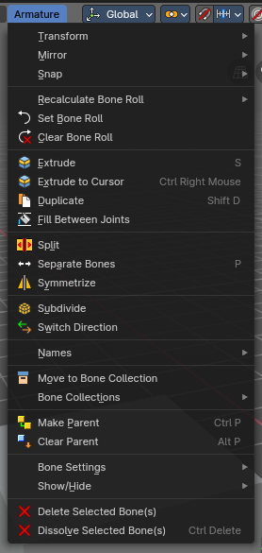
The Edit Mode for Armature objects has a number of operators in this header submenu to change and edit the default bone orientation, relationships and structure before using the Armature in Pose Mode for animation.

Transform - Submenu
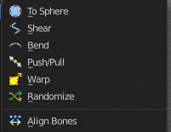

To Sphere
Shapes a selection of objects into the shape of a sphere. The calculation happens with the object origins.
In Object mode this tools requires to have more than one object selected.

Usage

Select the vertices, activate the tool, then drag the mouse in the 3D viewport. In the header you will read the current factor then. Which tells you how close you are towards the sphere shape. With a skeleton the to sphere operation is everything but accurate though. The bones gets stretched or compressed
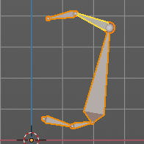

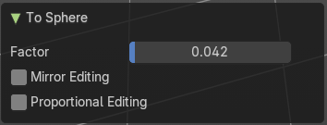
Last Operator To Sphere

Factor
The factor to transform the selection into a shape form.

Mirror Editing
Enable mirror editing.

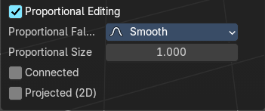
Proportional editing
Enables proportional editing. Activating proportional editing reveals further settings.

Proportional Falloff
Adjust the falloff methods.

Proportional Size
See and adjust the falloff radius.

Connected
The proportional falloff gets calculated for connected parts only.

Projected(2D)
The proportional falloff.

Shear
Shear shears the selection.
In Object mode this tools requires to have more than one object selected.
The shear tool works along a imaginary 2d plane. The shear axis controls if the items are sheared along the x or the y axes of this plane. This is the plane along which the transformation happens. You can shear along the x or the y axis of this plane.
To make things even more complicated, the orientation of this imaginary plane is defined by the Axis and Axis Ortho items below.

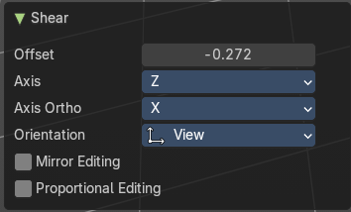
Last Operator Shear

Offset
Adjust an offset.

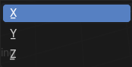
Axis
Defines one axis of the imaginary shear axis plane.

Axis Ortho
Defines the other axis of the imaginary shear axis plane.

Orientation
Choose the orientation for the shear action.

Mirror Editing
Enable mirror editing.

Proportional editing
Enables proportional editing. Activating proportional editing reveals further settings.

Proportional Falloff
Adjust the falloff methods.

Proportional Size
See and adjust the falloff radius.

Connected
The proportional falloff gets calculated for connected parts only.

Projected(2D)
The proportional falloff gets calculated in the screen space. Depth doesn't play a role. When it's in the radius, then it gets calculated.

Bend
Bends the selection.

Push/Pull
It pushes or pulls the object positions relative to the center of the selection.
In Object mode this tool requires to have more than one object selected.

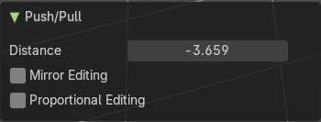
Last Operator Push/Pull

Distance
Adjust the distance of influence of the tool.

Mirror Editing
Enable mirror editing.

Proportional editing
Enables proportional editing. Activating proportional editing reveals further settings.

Proportional Falloff
Adjust the falloff methods.

Proportional Size
See and adjust the falloff radius.

Connected
The proportional falloff gets calculated for connected parts only.

Projected(2D)
The proportional falloff gets calculated in the screen space. Depth doesn't play a role. When it's in the radius, then it gets calculated.


Warp
Warps a mesh selection between two defined points.

Last operator Warp

Warp Angle
The strength of the warp effect

Offset Angle
An offset angle to bend sidewards.


Min
The start point.

Max
The end point.

Randomize Transform
This tool allows randomizes the positions of the selected vertices.


Last Operator Randomize Transform

Amount
Adjust the amount.

Uniform
The uniform offset distance.

Normal
Align the offset direction to the normals.

Random Seed
The seed value for randomization.

Align Bones
Aligns the selected bones to the orientation of the active bone.

Mirror

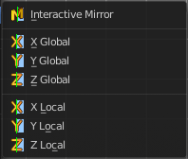
Mirror mirrors the selected geometry along the defined axis.

Interactive Mirror
Mirror by hotkeys. You activate the tool, type in x for x global for example, or x x for x local. And the selection gets mirrored

X Global, Y Global etc.
Mirrors the selection around the chosen axis.

Last Operator Mirror
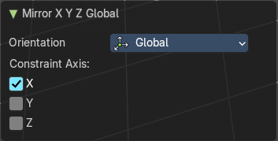
The Last Operator Mirror panel gives you tools to adjust the mirror action.


Orientation
Orientation is a drop-down box. Choose the type of orientation for the mirroring action.

Constraint Axis
Constraint Axis gives you again the possibility to define the mirror axis. You can choose more than one axis here.

Snap

Choose several methods to snap one element to another. The menu items should be self explaining.

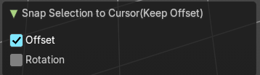
Last operator Snap Selection to Cursor
Some snap operations shows a last operation panel, some not.

Offset
If the selection should snap as a whole, or if each individual element of the selection should snap.

Rotation
If the selection should be rotated to match the cursor.

Recalculate Bone Roll - Submenu

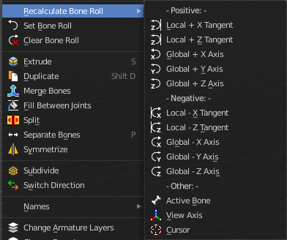
Recalculate Bone Roll Recalculate Roll is a menu where you can recalculate the bone roll in various ways.

The menu items are pretty self explaining. So we will not repeat the descriptions here.

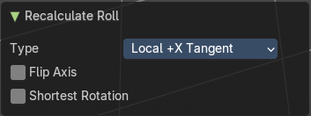
Last Operator Recalculate Roll

Type
Type is a drop-down box. Choose the recalculation method again.

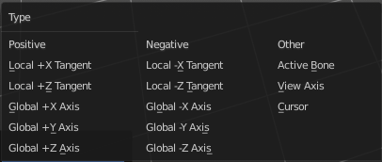
Flip Axis
Negates the alignment axis.

Shortest Rotation
Ignore the axis direction, and use the shortest rotation to align the bone(s)

Set Bone Roll
This operation is relative to the starting value, and starts always with zero. It does not display the Bone Roll value from the Transform panel. It adds or subtracts the amount of the operation to/from the Roll value then.
While operating you will see the current relative Roll value in the header.

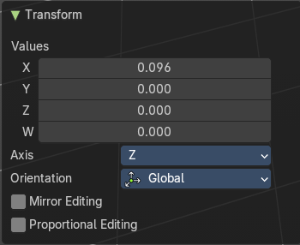
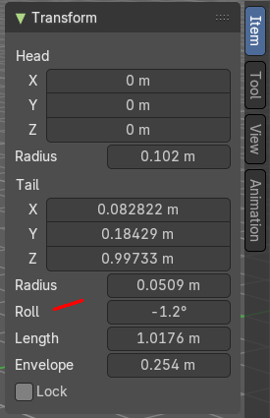
Last Operator Transform
The only interesting value is the X value right at the top. The other settings here are simply dysfunctional. You cannot turn on proportional editing, axis and orientation doesn't play any role since it always rotates around the bone orientation. And so we will not go into detail here.
Unfortunately even the X value to display the amount of the roll is broken. It displays the amount in Radians, while the Bone roll is in degrees.

Values
The vector 4 values.

Axis
Defines one axis of the imaginary shear axis plane.

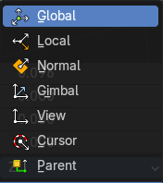
Orientation
Choose the orientation for the shear action.

Mirror Editing
Enable mirror editing.

Proportional editing
Enables proportional editing. Activating proportional editing reveals further settings.

Proportional Falloff
Adjust the falloff methods.

Proportional Size
See and adjust the falloff radius.

Connected
The proportional falloff gets calculated for connected parts only.

Projected(2D)
The proportional falloff.

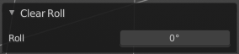
Clear Roll
Set the bone roll value directly.

Last Operator Clear Roll

Roll
Set the bone roll.

Single Operators

Extrude
Extrudes out a bone from the selected joints.

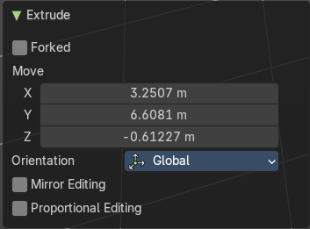
Last Operator Extrude

Forked
You need to tick X Axis Mirror. When you tick Forked, then the bone that you extrude to the one side will now be extruded to the other side too. The extrude gets mirrored along the x axis. This allows you to create a symmetrical armature.
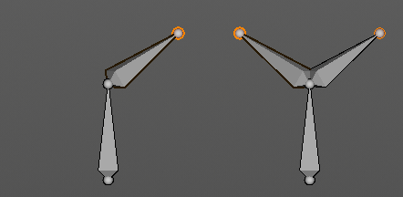
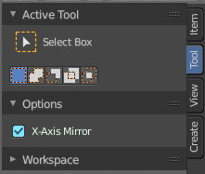

Move X , Y, Z
The transform values for the new created joint(s)

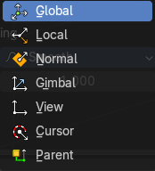
Orientation
Orientation is a drop-down box. Choose the type of orientation for the mirroring action.

Mirror Editing
Enable Mirror Editing.

Proportional editing
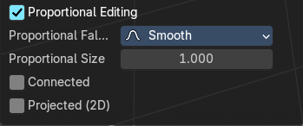
Enables proportional editing. Activating proportional editing reveals further settings.

Proportional Falloff
Adjust the falloff methods.

Proportional Size
See and adjust the falloff radius.

Connected
The proportional falloff gets calculated for connected parts only.

Projected(2D)
The proportional falloff gets calculated in the screen space. Depth doesn't play a role. When it's in the radius, then it gets calculated.

Extrude to Cursor
Hotkey only tool. Extrude to the mouse position.

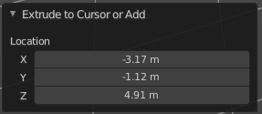
Last Operator Extrude to Cursor or Add

Location X Y Z
The location to extrude to.

Duplicate
Duplicates selected bones.
You are automatically in grab mode, and so you can easily move the object out of position. Which is sometimes wanted, since you can position the duplicate then. But sometimes this is unwanted. A right click after releasing the mouse lets the object snap back into its creation position.
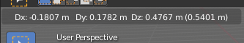
When you drag the duplicate around you will see the position values in the header.

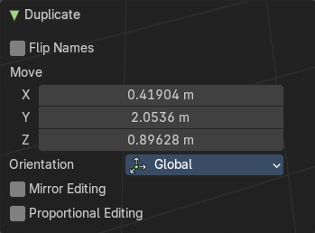
Last Operator Duplicate

Duplicate Objects

Flip Names
Tries to flip the names of the bones. This is a name convention feature. When you have a bone called mybone.R, then it tries to become mybone.L

Move X , Y , Z
The Position of the duplicated object.

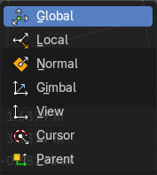
Orientation
Orientation is a drop-down box choose the type of orientation for the mirroring action.

Mirror Editing
Enable Mirror Editing.

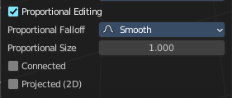
Proportional editing
Enables proportional editing. Activating proportional editing reveals further settings.

Proportional Falloff
Adjust the falloff methods.

Proportional Size
See and adjust the falloff radius.

Connected
The proportional falloff gets calculated for connected parts only.

Projected(2D)
The proportional falloff gets calculated in the screen space. Depth doesn't play a role. When it's in the radius, then it gets calculated.

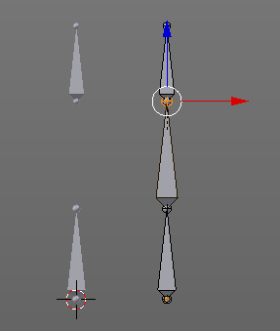
Fill between Joints
Fill between joints fills a bone between two selected joints.
When there is just one joint selected, then the bone is created between this selected joint and the 3D cursor.

Split
Split splits the selected bone(s) from connected bones. They are still part of the armature. But the bone is now floating. And you can pull this bone(s) around without pulling the rest of the armature around.
The Last operator for Split has no content.

Separate Bones
Separate separates the selected bone(s) from the armature. And creates a new, independent, armature.
The Last operator for Separate has no content.

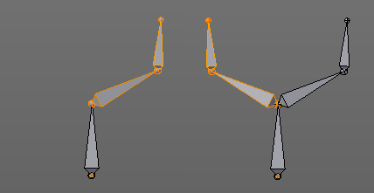
Symmetrize
Creates a symmetrical mirrored copy of the currently selected bones along the X axis. The mirror centre is the pivot of the armature.

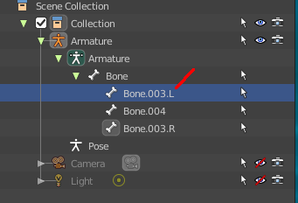
The bones that you want to symmetrize needs to follow the left right name conventions for bones. Bones without this left right naming are not affected by the tool. If there is a lower or upper case “L”, “R”, “left” or “right” with a separating dot in the bone name, then this tool creates and renames the bones names to its counter part. Bone.L becomes Bone.R.

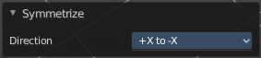
Last Operator Symmetrize

Direction
Define the calculation direction. From -X to + X or from +X to -X

Subdivide
Subdivide subdivides the current selection.

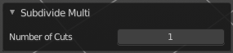
Last Operator Subdivide Multi

Number of Cuts
Adjust the number of subdivisions.

Switch Direction
Switches the direction in which the selected bones are pointing.

Names - Submenu
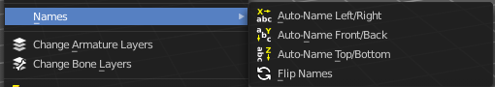
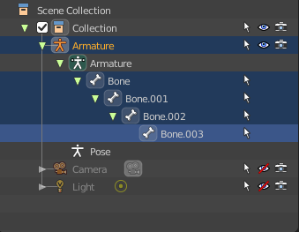
Bforartists has some internal name conventions for a symmetrical armature. Bones are for example named mybone.L or mybone.R, dependant at which side of the mirror axis they are. The Names items allows you to rename the bone names to this name convention.

Autoname Left/Right
Renames the bones from left to right.

Autoname Front/Back
Renames the bones from front to back.

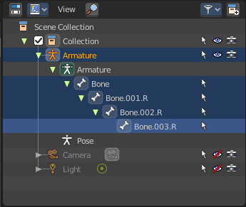
Autoname Top/Bottom
Renames the bones from top to bottom.

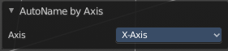
Last operator Autoname by Axis

Axis
Choose the autoname axis again. Left/Right is X axis, Front/Back is Y axis, and Top/Bottom is Z axis.

Flip Names
When you mirror a half of an armature you end in names like Bone.001.R.001. But what we need is Bone.001.L for a symmetrical armature. Flip names flips the names to follow the left right name conventions.

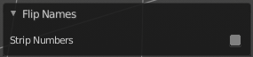
Last operator Flip Names

Strip Numbers
Tries to remove the numbers in the names if possible.

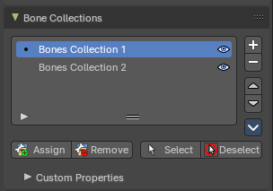
About Bone Collections
Bone Collections is a menu to handle bone collection functionality from within a menu in the 3D View editor. The bone collections themselves can be found in the Properties editor then in the Armature tab.

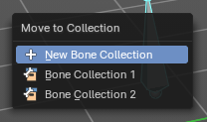
Move to Bone Collection
Armature and bones have their own collection system. This menu item opens a popup where you can put the selected bones into a New Collection or an existing Bone Collection.

New Bone Collection
Assigns the selected bones to a new Bone Collection. This will prompt to name the new collection.

Bone List
Assigns or unassigns the selected bones to or from the collection. The green + icon and red – icon show if you can remove or add a bone to the listed collection.

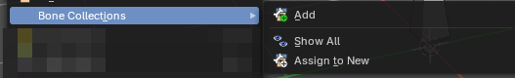
Bone Collections – Sub Menu
Armature and bones has its own collection system.

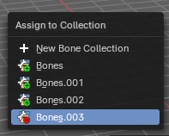
Add
Add or remove the bone from the listed bone collections. The green + icon and red – icon show if you can remove or add a bone to the listed collection. A bone can be in multiple collections at the same time.

New
Assigns the selected bones to a new Bone Collection. This will prompt to name the new collection.

Bone List
Assigns or unassigns the selected bones to or from the collection. The green + icon and red – icon show if you can remove or add a bone to the listed collection.

Show All
Show all bone collections.

Assign to New
Add selected bones to a new collection with a new name.

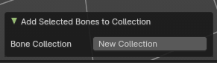
Last Operator Add Selected Bones to Collection

Bone Collection
Change name of the new collection.

Make Parent
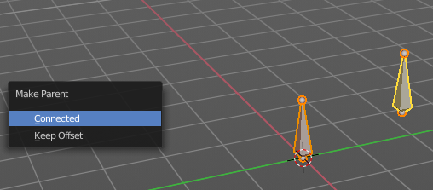
Adds a parent relationship.
Select a bone, hold down shift, select the bone that you want to parent it to. Perform Make Parent. In the pop-up choose the method that you want to use.

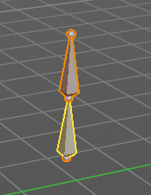
Connected
The child bone will jump to the position of the tail joint of the parent bone.

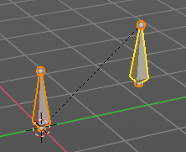
Keep Offset
The bone will remain in its original position. The relationship will be displayed by a black dotted line.

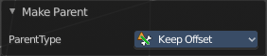
Last Operator Make Parent

Parent Type
Choose between Connected and Keep Offset method again.

Clear Parent
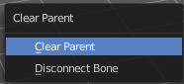
Clears the parent relationship of the selected bone(s). It calls a pop-up menu. Choose between two methods.

Clear Parent
Clears the parent relationship of the selected bone(s).

Disconnect Bone
The parent ship is kept. Turns a Connected parent relationship into a Keep Offset parent relationship. You can move the disconnected bone around without to pull the parent with it.

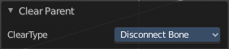
Last Operator Clear Parent

Clear Type
Choose between Clear Parent and Disconnect Bone method again.

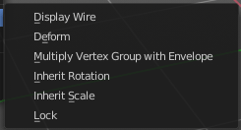
Bone Settings - Submenu
Bone Settings is a menu with menu items to toggle special checkboxes in the Properties editor. But here you can do it for a selection too, and not just one object.

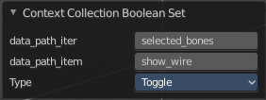
Last Operator Collection Boolean Set
Each of the menu items uses the same Last Operator. With different strings for the booleans.

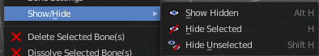
Show/Hide – Submenu
Show or hide the selected bones in the viewport.

Show Hidden
Makes all bones visible again.

Hide Selected
Hides the selected bones.

Hide Unselected
Hides the not selected bones. The selected bones stays visible.

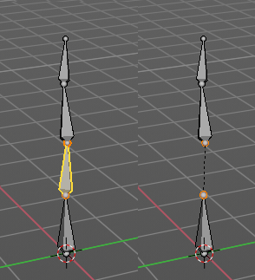
Delete Selected Bone(s)
Deletes the selected bones. The hierarchy is kept. The involved bones becomes disconnected.

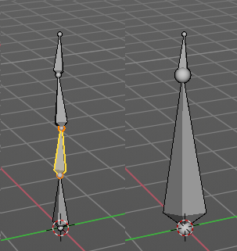

Dissolve Selected Bone(s)
Merges the selected bone or joint with its hierarchical neighbour bones.

